CRSS 8010 - Midterm 2
Emmeans
GGPLot
Data transformation
Sums of squares
Linear regression

Question 1 (2 points)
You are designing an experiment in the greenhouse to test responses of 6 turfgrass varieties to 4 different herbicides, each of which can be applied to individual pots with a hooded sprayer. Each bench holds 50 pots, and you want a total of four replicates. What design would you choose for this experiment? Justify your answer.

Question 2 (4 points)
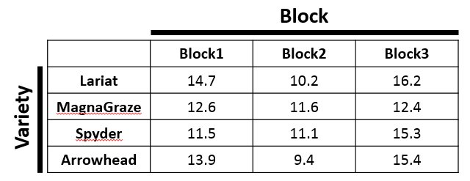
Using the above table of yield values, answer each of the following questions. Round your answers to two decimal places.
- What is the sum-of-squares for Block 1? (Not all blocks, just Block 1).
- What is the total sum-of-squares? (Meaning across the entire experiment, not just across all blocks.)
- What is the ANOVA p-value for Variety?
- How many degrees of freedom do you have for error after including block x variety interaction?

Question 3 (3 points)
Download the dataset “midterm2_cotton.csv.” This data is for cotton fiber quality evaluated across 8 varieties in a strip-plot design, with irrigation and fertilizer as the two strip (whole-plot) effect and variety as the subplot effect. (That is, multiple varieties are planted in each place the fertilizer and irrigation strips intersect.) We are interested in the main effects of fertilizer, irrigation, and variety, and the irrigation x fertilizer interaction. The column headings correspond to:
- Quality: cotton quality
- Fert: Level of fertilizer added
- Irrigation: Type of irrigation used
- Fert_strip: unique label for each fertilizer strip
- Irr_strip: unique label for each irrigation strip
- Variety: Name of the cotton variety
Run an analysis treating both strips as random effects. Which fixed effects are significant at p<0.05?

Question 4 (3 points)
You’re collaborating with a startup company looking to grow seaweed for carbon capture. The data from their first pilot project is in ‘midterm2_seaweed.csv’, which is a factorial RCBD experiment testing different netting compositions (“substrate”) and spacings on biomass production. Using a basic linear model (=only fixed effects), which sums of squares is the appropriate one for this dataset? How do you know? Which model term(s) is/are significant at p<0.01?

Question 5 (3 points)
You are performing statewide variety tests of 30 different cotton varieties at eight locations around the state of Georgia under three levels of nitrogen fertilizer. When fitting a linear mixed model to the data, do you code “variety” as a fixed or random effect? What about location? What about nitrogen level? For each answer, explain your choice.

Question 6 (2 points)
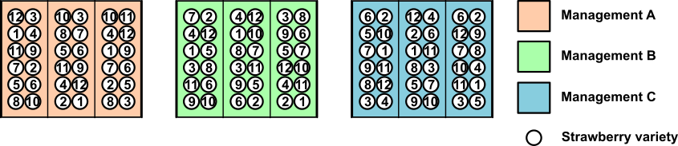
Your labmate comes to you wanting to test the effect of different ways of attracting predatory insects to control pests in 12 varieties of strawberries. Due to the nature of the treatments, they know they will need a split-plot design. They come to you with the above sketch of their plan. What is wrong with this design, and how should they fix it?

Question 7 (3 points)
Your friend at Emory has asked for some help analyzing results of an experiment looking at vitamin supplements and bone density; their data are in ‘midterm2_bones.csv’. Participants (teenage children, ages 12-16) were divided into blocks based on their locations, and each child in a block was randomly assigned one of the treatments. All children were measured at the end of each school year for a key bone density biomarker (“outcome”), and any given child’s treatment stayed the same from year to year. Assuming more biomarker is better, which treatment(s) should your friend recommend to physicians to increase bone density for their patients?

Question 8 (1 point)
You are running a trial of 5 fertilizers and 3 irrigation types on organic peaches, and you are interested in both main effects and their interaction. The orchard you are using has one area with a single peach variety, which you have set up as a strip-plot experiment with 3 replicates in RCBD. From the point of view of an ANOVA analysis, how many different error terms will be in this experiment?

Question 9 (3 points)
You are testing several seed treatments to boost germination of maize under cold conditions. You have 25 maize varieties you’re germinating in a cooled growth chamber in a RCBD. You plant four of each variety in a pot and 5 pots per variety, for a total of 20 plants per variety and 500 plants total.
- How many independent observations do you have?
- How many degrees of freedom are there for error?

Question 10 (5 points)
Your (questionably sane) colleague has decided to test pine tree varieties for wood production in a massive split-split-splitplot design. The whole plots are environmental conditions (mountains versus coastal plains), the subplots are a factorial combination of 3 planting densities and 4 pre-planting soil treatments, the sub-subplots are 5 types of insect control, and the sub-sub-subplots are 18 varieties of loblolly pine.
- How many experimental units are in a single complete replication of this experiment?
- How many different error terms will the ANOVA analysis of this experiment include?
- If there are 3 replicates of each whole plot, how many independent observations are there for each level of planting density?

Question 11 (1 point)
You are running a full factorial experiment with 10 barley varieties and 4 levels of pesticide application. You have three replicates, each laid out as a randomized complete block. How many degrees of freedom are there for error if you ignore variety x pesticide interactions?

Question 12 (1 point)
For the above question, how many DOF are there for error if you include interactions?

Question 13 (6 points)
Download the dataset ‘midterm2_turfgrass.csv’ from eLC. This file contains results from a turfgrass field trial evaluating persistence on a 0 to 9 scale. With this data, perform the following analyses. (You can put everything, including images, below, or upload them as a separate R notebook file).
- Are there any problematic data points? How do you know? (If there are problematic points, filter them out for the remaining analyses.)
- Run an ANOVA analysis on this data including all main effects and the interaction between fertilizer and variety. Which factor(s) show a significant effect?
- For each of the factors that are significant, determine which factor level(s) should be grouped together (=are equivalent). If you had to recommend something to a farmer, which one(s) would you recommend and why?

Question 14 (3 points)
Load in the data ‘midterm2_pecans.csv’, which is a strip-plot analysis testing the effect of different tree spacings and hedging (=pruning) patterns on pecan production. Analyze this experiment. Which treatment(s) would you recommend to a grower based on this data?

Question 15 (2 points)
Your labmate is testing some new germplasm in their canola breeding program. They don’t have much seed, so they’re planning on growing everything in an augmented design with 20 varieties + 3 checks per block, so that the whole experiment uses 50 blocks to test 1000 total new varieties. Unfortunately, two weeks before planting the seed room flooded, leaving them with only 894 varieties and enough seed to put check A in 8 blocks and check B in 31 blocks. (Check C was on a high shelf and so still has plenty of seed.) Can this experiment be salvaged? If so, what changes, if any, would need to be made in the analysis to accommodate the new situation?

Question 16 (2 points)
Look at Question 14 again. Are you sure you analyzed it appropriately? How do you know? (Hint: did you make sure to check your assumptions?) If you missed something the first time, how do your results change once it’s corrected?

Question 17 (4 points)
What about the rest of this exam? Are you sure all the analyses you did are correct? I only pointed out issues for you in some of the datasets that have them; there are others I did not. Which one(s) is/are problematic? How do you know? How do your results change after fixing the problem?
(Note: I’m not trying to trick you, but I am trying to make you a little paranoid. Assuming your data is clean is a risky assumption to make in real work, so best to start good habits now.)

